 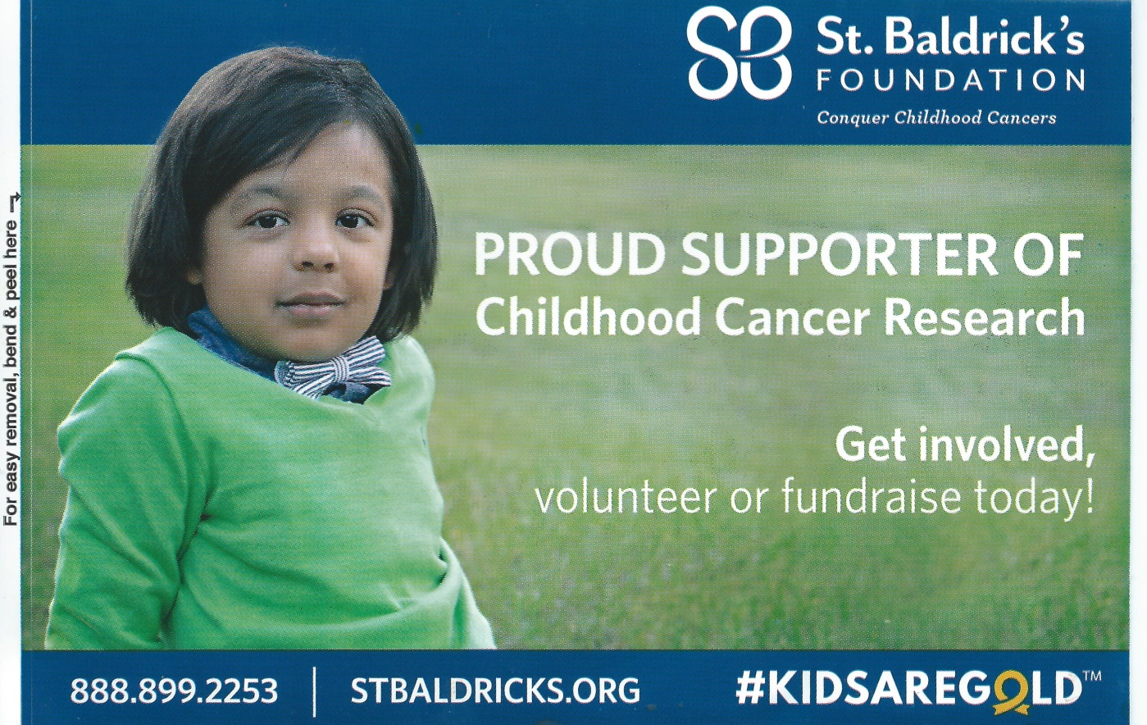

Hello CBI Affiliates!

It is 9 weeks until ICSA and CBI’s Shave for the Brave event!

That’s @64 days left for all of us to be raising money for this very worthwhile cause.

Last month you received information on this, along with suggestions to get you and your affiliate members involved.

We are hoping by now that you have possibly found someone within your affiliate, friends or families that you can rally behind as they participate as a “Shavee”! You need to be getting them listed on the St. Baldrick’s webpage if you haven’t done so already.

As of this writing, CBI has just one (1) official Shavee. This is our own board member, secretary/treasurer Jenni White.

Remember the more participants, the more fun and exciting this event will be for all of us to watch. And as a reminder, the goal CBI and ICSA set is at $10,000!

Attached to this email are some files that you and your members will find useful in helping to raise funds. We ask that you either see to it that they get printed or send this email on to each of your members so they may print them.

Included is a poster for front desks, windows, etc., a small decal and logos like the ones above for both CBI and St. Baldrick’s that can be put onto jars, boxes etc. for all the MONIES you will be collecting!!!

If in need of any more information, feel free to contact your CBI Board members:

Tammy (319) 239-0565 Sue (319) 239-8154 Jenni (319) 830-0254

THANK YOU CBI MEMBERS FOR HELPING THIS EVENT BE A SUCCESS!

SEE YOU AT “NEW BEGINNINGS” EDUCATION DAY AND DELEGATE SESSION